Current Hub

Export Csv

Filter by Status

Search

Add Current Hub column: This shows the current hub that the package is in at the moment.

ON the “At the Hub” page, when I click on create transit bag, It should take me to where I can create transit bag.

Add status column to the table. When the transit bag is in Transit, I should see it. When all packages have been received from the transit bag, the status should change to received.

Add select Origin Hub. Origin Hub and destination Hub cannot be the same.

TransitBag

I should be able to search Transit Bag.

Add transit bag option when package is expanded. This will display the transit bag number of the package if it has been assigned to one.

Add “At the Hub” status to status I can see under “At the Hub” Tab.

Click Driver Sheet.

Select Driver: Driver list will come from user list.

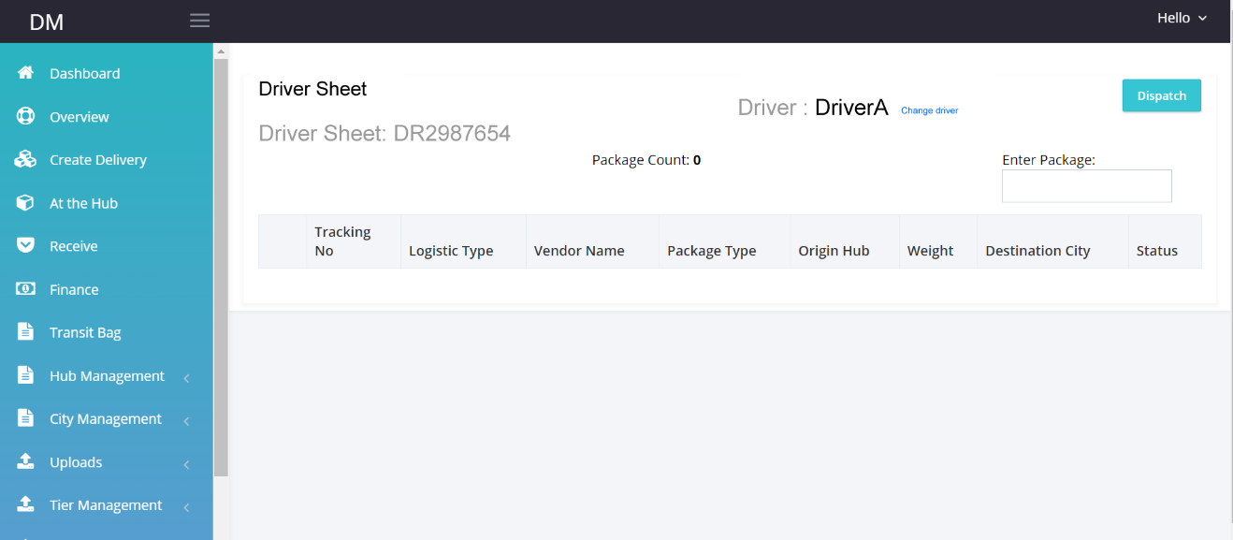

Origin Hub

Packages with the “At the Hub status should be allowed to enter driver sheet.

Once Dispatch is clicked, User needs to confirm.

After confirm all packages in the driver sheet changes status to “In Delivery”

Dispatched Runsheet will be under Finance Tab.

**User Management Tab**

**Add user type “Driver”** to the user module.

Such that I can create access to drivers from user management.

Create subdomain

Driver.opmovings.com

This will be used by drivers to login

When a driver logs in to this page he is able to see all packages that has been assigned to him.

This page should be mobile responsive

Customer Name:

ICL23565899

Address:

Are you sure you want to cancel the package?

**YES** or **NO**

Deliver

Failed

**Confirm Delivery**

**YES or NO**

Submit

Enter Failure Reason